**Agro-Advisory Service**

**Vatsalkumar Patel (AU2040043), B.Tech. Computer Science And Engineering**

**Ahmedabad University**

**Faculty Guide: Prof. Sanjay Chaudhary**

The agricultural industry is vital for increasing food security and economic growth. In these times, the knowledge of the latest information may be inaccessible to the farmers. The absence of this kind of informed decisions means that their choices will be limited and could lead to losses. This initiative was designed to close this gap through the establishment of a web-based comprehensive information system, which combines geospatial data, machine learning, and user friendly features to enable farmers to make well- informed and efficient agricultural decisions, as it is a critical factor for increasing the efficiency of agricultural production.

The platform is implemented using cutting-edge technologies, such as GIS layers, OpenLayers mapping API, and PostgreSQL with PostGIS, Apache Tomcat, and GeoServer. It supplies maps that are adaptable, for geo-spatial data such as soils, weather, which shows crop distribution, and market places. Machine learning Light Gradient Boosting model integrated into the website is one of the most accurate, providing recommendations for crops based on specific soil and weather conditions with more than 99% accuracy.

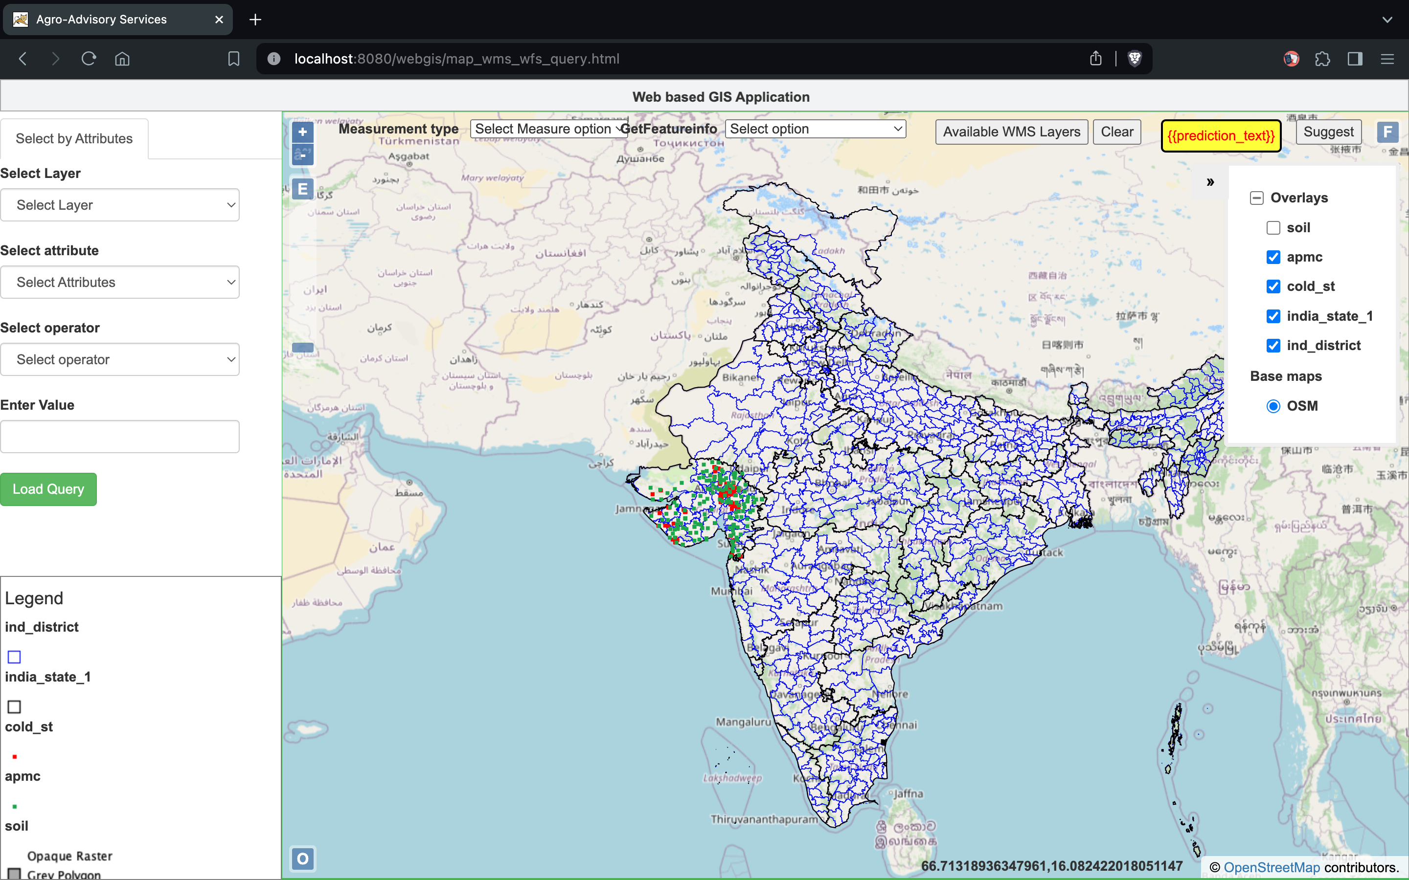

The system has very substantial potential applications in real world. For example, it can be used for precision farming which will result in higher yields; crop suitability analysis, farm planning and management; scientific monitoring of environment; agricultural outreach services. It gives the power to farmers by providing them with both the up-to-date and the actionable information that can drive sustainability and productivity.

It could be a platform through which more facilities can be made available and the agricultural sector can be fully synergetic with the ever-emerging technologies in agriculture issues, decision-making, and management.